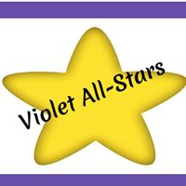

Welcome to the Violet School Library !
We offer many resources on our site that are available to all of the students at school, as well as at home. We encourage you to browse the site with your kids and play around to see what’s out there. Below is an overview of what you can find on each of our pages.
HOME
On our home page you will have a direct link to our library through Destiny Quest, where you can search for all of the books on our shelves. This is also where you will find out about anything new happening.
RESEARCH
On the research page there are links to an online dictionary, thesaurus, and a kid-safe engine call Cybersleuth-Kids. We also offer our students World Book, an online encyclopedia. Just need a few quick facts? Check out the online Almanac, Fact Monster. You will also find links to the St. Clair Shores Public Library and Mel.org, the Michigan eLibrary.
READING/EDUCATIONAL SITES & GAMES
We are very excited to be able to offer Tumble Books to all of our students. There are so many books to choose from for all grade levels, including storybooks that are read aloud with illustrations, as well as chapter books. It’s a wonderful resource that we hope you will enjoy often. We also include links to other reading sites, fun links to help with math and links to other great learning games.
TECHNOLOGY
Each grade level has their own set of links for practice using their typing and computer skills.
Your Librarian,
Mrs. Porter

